TOP FRAME WIRING

- PARTS:

- EMERGENCY STOP 2:

QUANTITY: PART #: NOMENCLATURE: LENGTH:

2 PER MACHINE 19111- WIRE, WHITE / RED, 22 AWG 90 INCHES

1 PER MACHINE 19105- WIRE, BLUE, 20 AWG 90 INCHES

1 PER MACHINE 19107- WIRE, ORANGE, 20 AWG 90 INCHES

1 PER MACHINE 46812-1 SWITCH, E-STOP N/A

1 PER MACHINE 46776- SLEEVE, ¼” BLACK 85 INCHES

1 PER MACHINE 17597- CONNECTOR, PLUG N/A

8 PER MACHINE 17598- TERMINAL, SOCKET N/A

1 PER MACHINE 18612-4 CLAMP, CABLE N/A

B. EMERGENCY STOP 1:

QUANTITY: PART #: NOMENCLATURE: LENGTH:

2 PER MACHINE 19111- WIRE, WHITE / RED, 22 AWG 120 INCHES

1 PER MACHINE 19105- WIRE, BLUE, 20 AWG 120 INCHES

1 PER MACHINE 19107- WIRE, ORANGE, 20 AWG 120 INCHES

1 PER MACHINE 46812-1 SWITCH, E-STOP N/A

1 PER MACHINE 46776- SLEEVE, ¼” BLACK 115 INCHES

C. RESET SWITCH:

QUANTITY: PART #: NOMENCLATURE: LENGTH:

1 PER MACHINE 19036- WIRE, WHITE / ORANGE, 20 AWG 124 INCHES

1 PER MACHINE 19005- WIRE, BLUE, 20 AWG 124 INCHES

1 PER MACHINE 18689-1 SWITCH, MOMENTARY, OPERATOR N/A

1 PER MACHINE 18689-2 SWITCH, MOMENT., CONTACT BLK N/A

1 PER MACHINE 46776- SLEEVE, ¼” BLACK 119 INCHES

D. MAIN POWER SWITCH:

QUANTITY: PART #: NOMENCLATURE: LENGTH:

2 PER MACHINE 19119-- WIRE, WHITE, 16 AWG 124 INCHES

2 PER MACHINE 19120-- WIRE, BLACK, 16 AWG 124 INCHES

1 PER MACHINE 19126-- WIRE, ORANGE, 16 AWG 124 INCHES

1 PER MACHINE 19124-- WIRE, BLUE, 16 AWG 124 INCHES

1 PER MACHINE 19121-- WIRE, GREEN, 16 AWG 114 INCHES

1 PER MACHINE 18675-1 SWITCH, POWER, GREEN N/A

1 PER MACHINE 17087-1 TERMINAL, RING N/A

1 PER MACHINE 17597-3 CONNECTOR, PLUG N/A

9 PER MACHINE 17595-1 PIN, CONTACT N/A

1 PER MACHINE 18612-2 CLAMP, CABLE N/A

1 PER MACHINE 46777- SLEEVE, ½” BLACK 119 INCHES

E. TOWER LIGHT SWITCH:

QUANTITY: PART #: NOMENCLATURE: LENGTH:

1 PER MACHINE 19210- CABLE, 20 AWG, 4-CON 130 INCHES

1 PER MACHINE 46776- SLEEVE, ¼” BLACK 72 INCHES

4 PER MACHINE 17586- TERMINAL, CRIMP, MOLEX N/A

1 PER MACHINE 17585-3 HOUSING, 4-PIN, MOLEX, N/A

QUANTITY: PART #: NOMENCLATURE: LENGTH:

1 PER MACHINE 17025- CONNECTOR, FEMALE, 2 SOCKET N/A

2 PER MACHINE 17023- SOCKET, CONNECTOR N/A

2 PER MACHINE 17022- PIN, CONNECTOR N/A

1 PER MACHINE 17024- CONNECTOR, 2-PIN, MALE N/A

F. DOOR SWITCHES:

QUANTITY: PART #: NOMENCLATURE: LENGTH:

1 PER MACHINE 19210- CABLE, 20 AWG, 4-CON 150 INCHES

2 PER MACHINE 18717- SWITCH, DOOR GUARD N/A

2 PER MACHINE 18717-1 NUT, DOOR GUARD SWITCH N/A

4 PER MACHINE 17511-2 TERMINAL, QUICK DISCONNECT N/A

1 PER MACHINE 17024- CONNECTOR, 2-PIN, MALE N/A

2 PER MACHINE 17022- PIN, CONNECTOR N/A

1 PER MACHINE 46776- SLEEVE, ¼” BLACK 30 INCHES

- ASSEMBLY:

- MANUFACTURE ALL ASSEMBLIES ACCORDING TO DIAGRAMS 1 THROUGH 3.

8” 20”
8”

142”

DIAGRAM 1

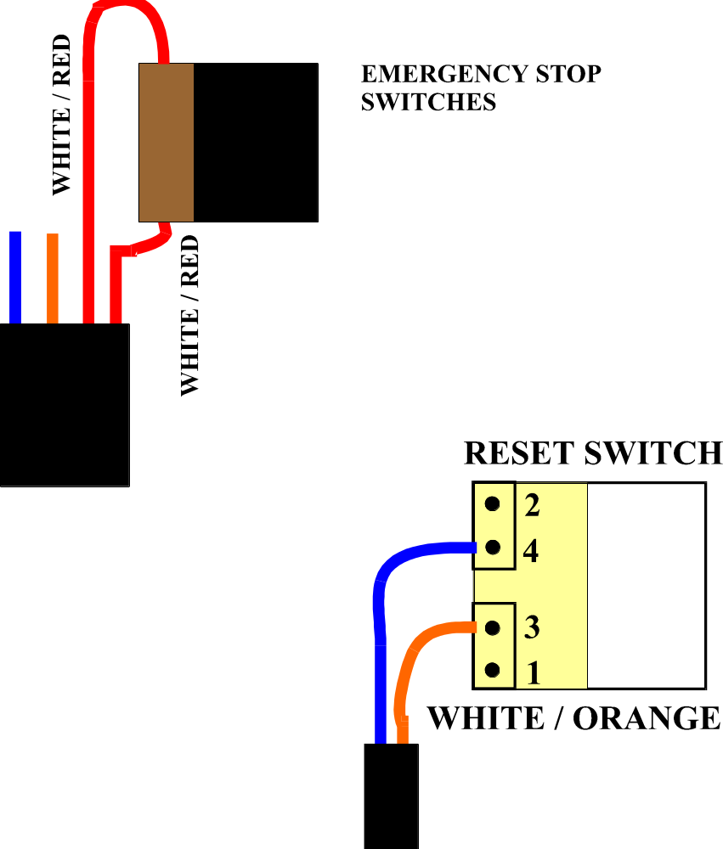

DIAGRAM 2

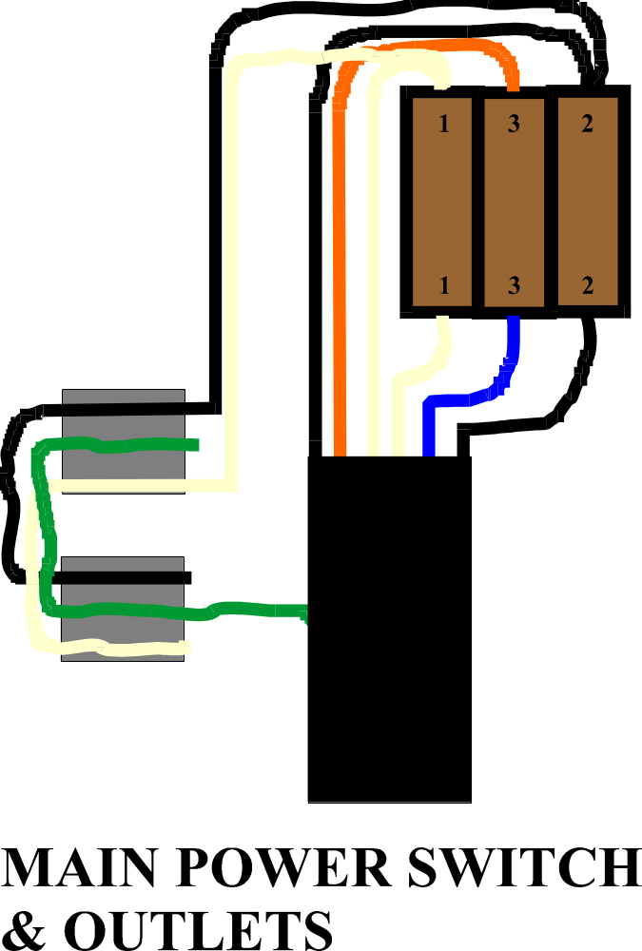

DIAGRAM 3

